Nursery Topic Books

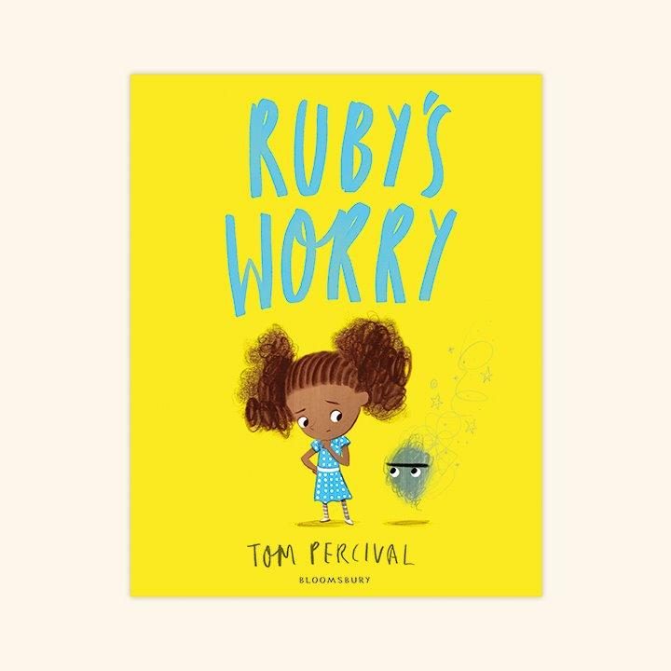
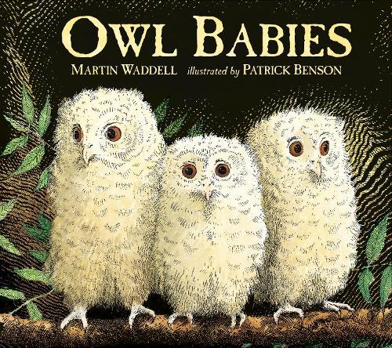
Autumn 1 – “All About Us”

Personal, Social & Emotional Development
- Ruby’s worry
- Owl babies
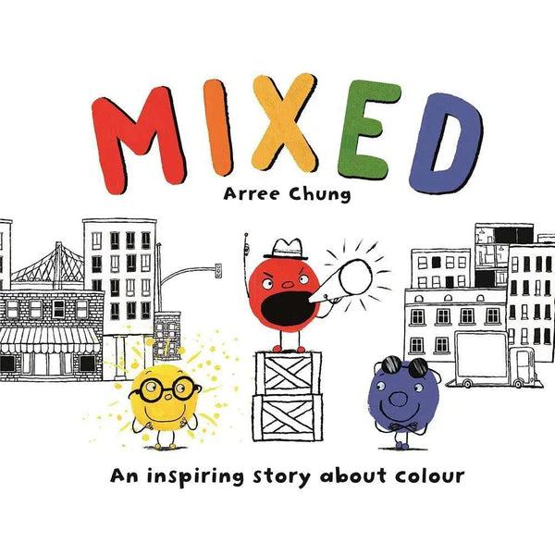
Autumn 2 – “Big feelings, helping hands”

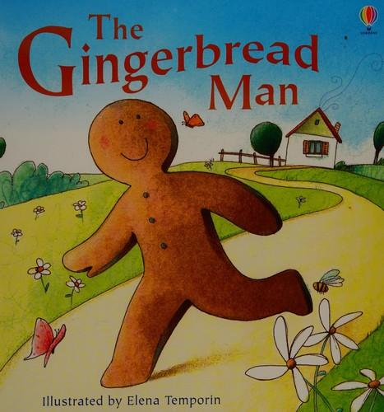
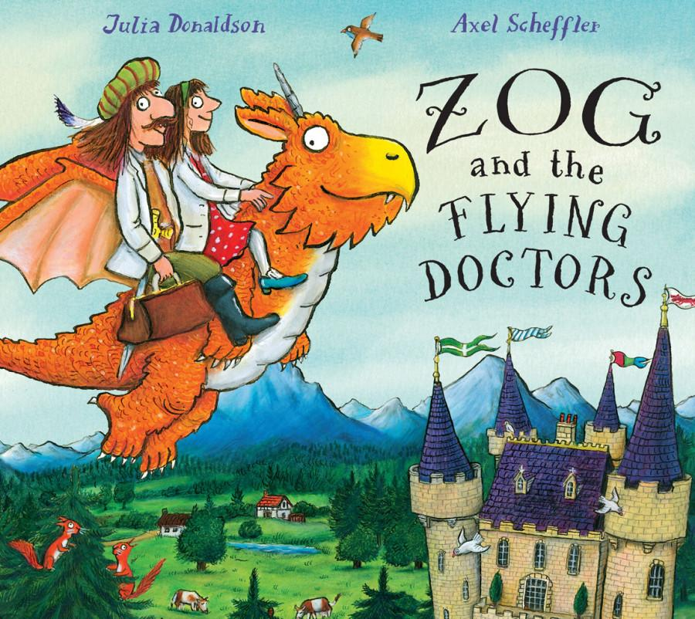
People & Communities
- Zog and the Flying Doctors
- Mixed
- Gingerbread man - Traditional tales
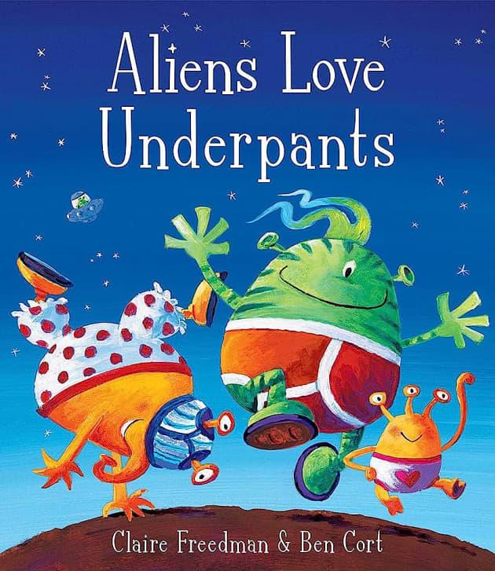
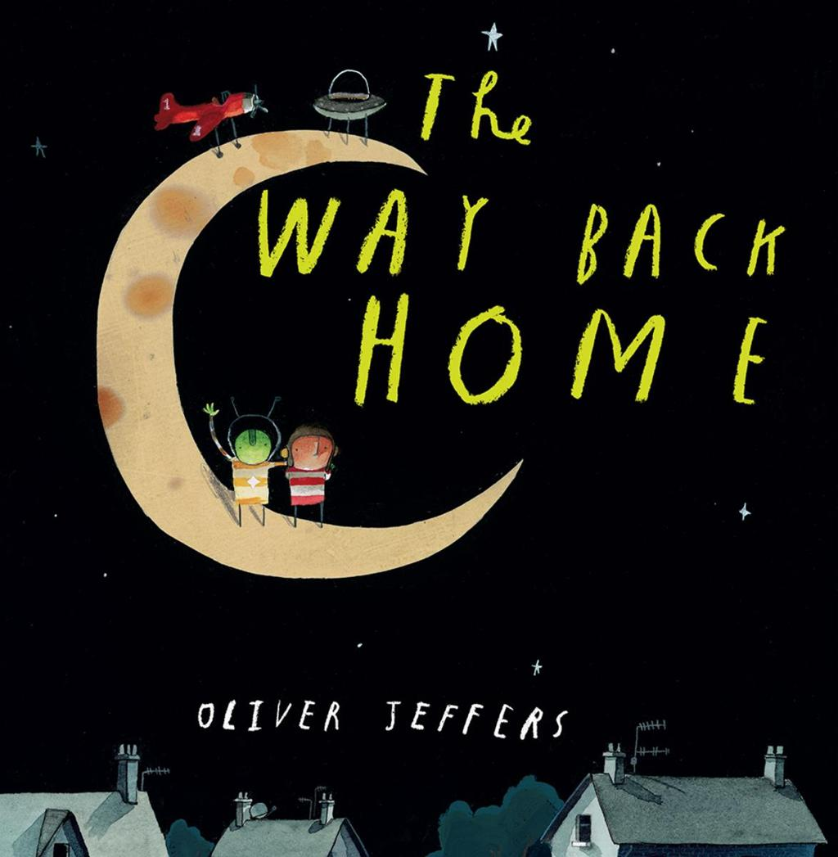
Spring 1 – “Space”

- The way back home
- Aliens Love Underpants

Spring 2 – “Growth & Change”

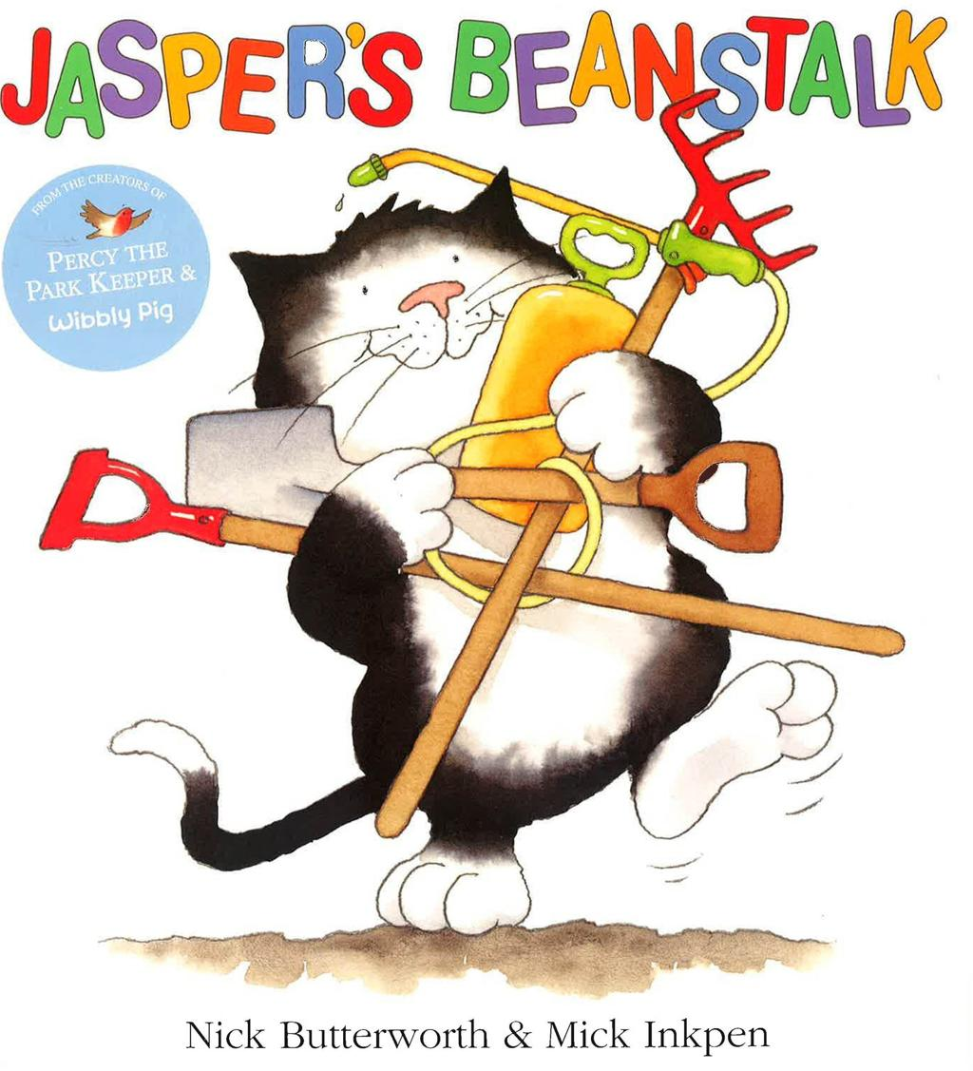
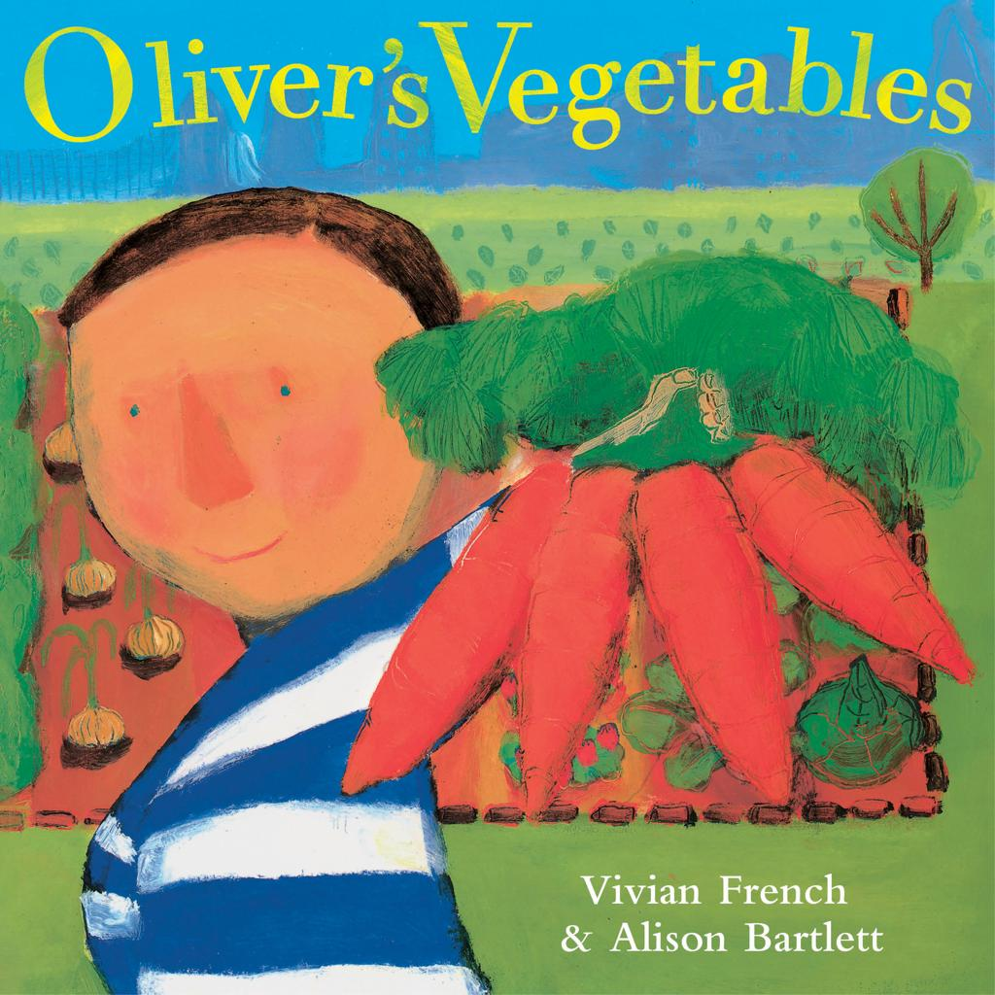
Plants & Growing
- Jaspers beanstalk - Traditional Tails
- Oliver’s Vegetables
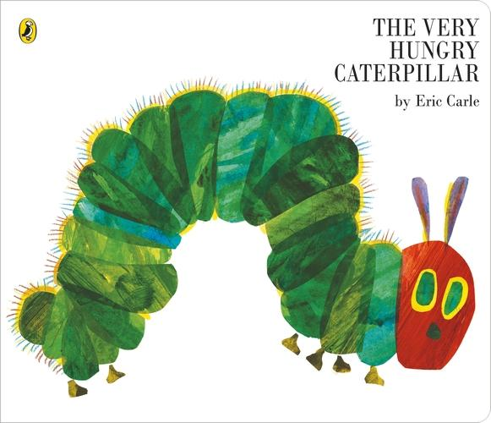
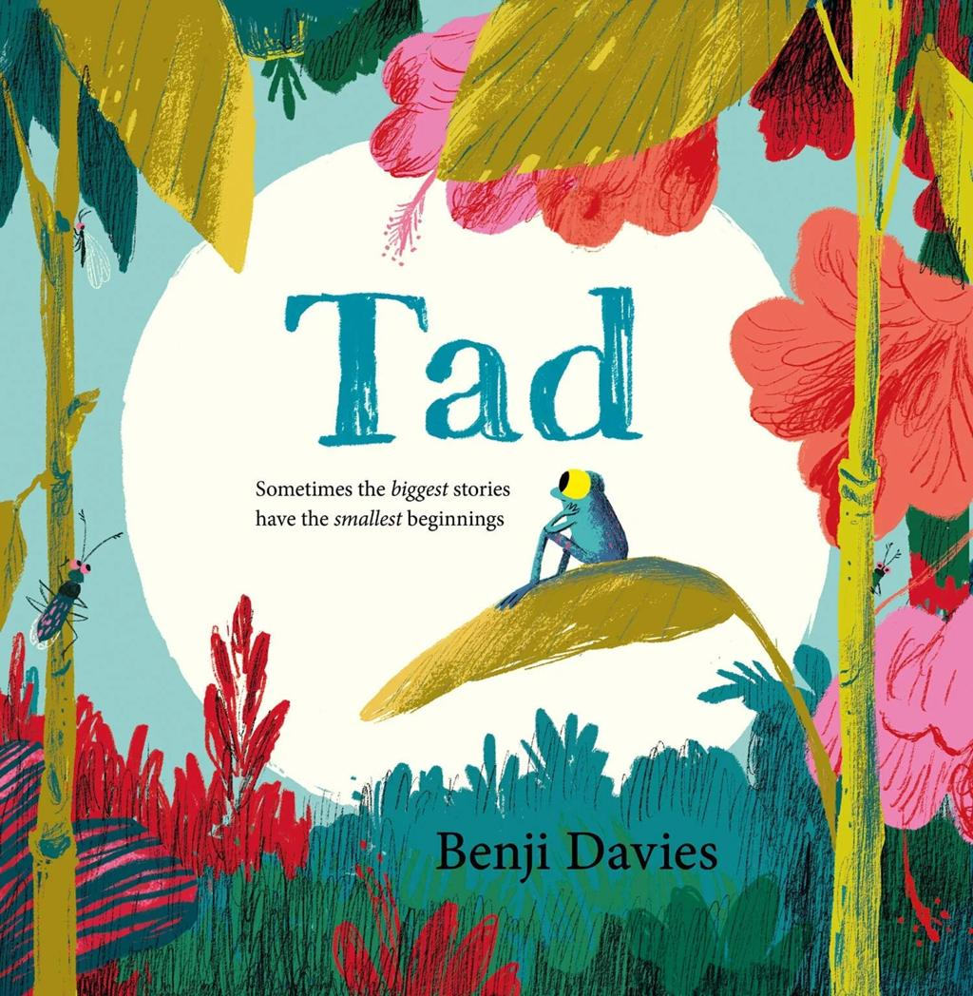
☀️ Summer 1 – “Growth & Change”

Life Cycles & Nature
- Tad
- The Very Hungry Caterpillar

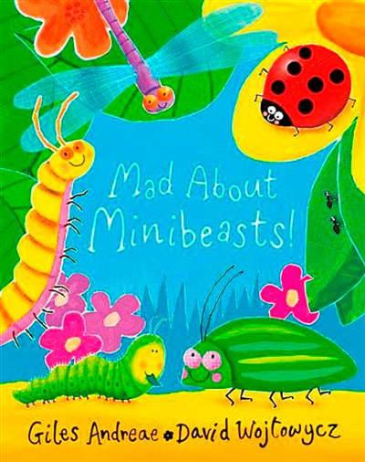
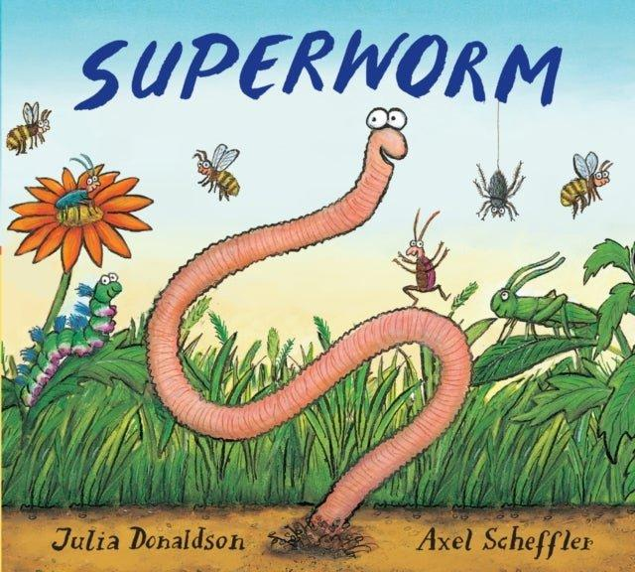
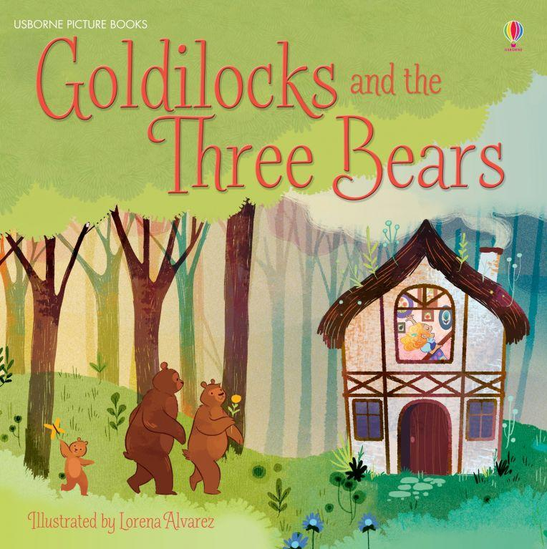
Summer 2 – “Minibeasts”
- Superworm
- Mad About Minibeasts
- Goldilocks and the three bears - Traditional tales

