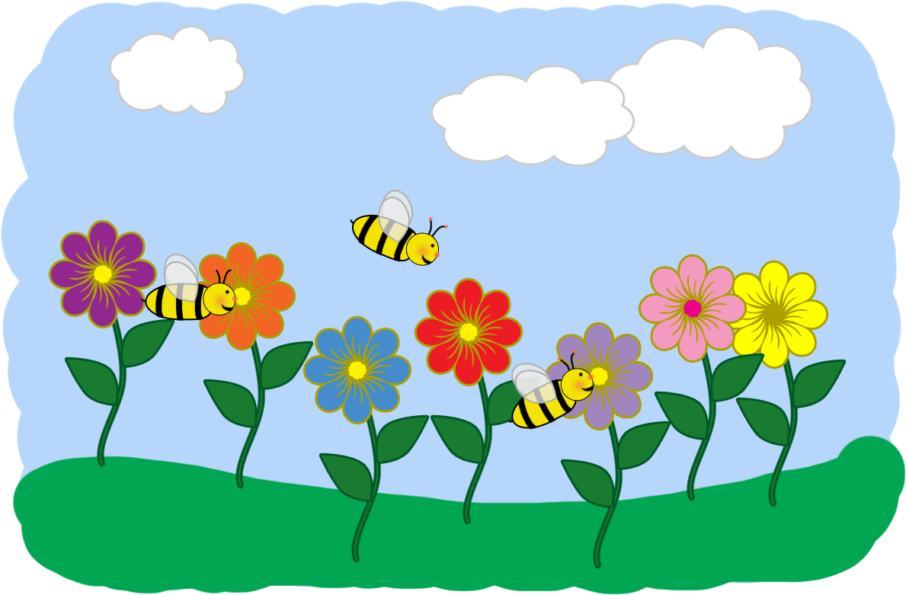
Homework
Year | 1
Date | Monday 10th June 2019
Date due / Complete | Monday 17th June 2019
Spelling | Spelling on the school website - Yr1 (Summer 2)
Reading | *Reading at least 3 times a week.  Write the title, the author and illustrator for one of your books. Then, if you were able to change the ending of the book, what ending would you create and why?  This can be done on the back of your homework sheet.
Literacy | Complete ‘the very hungry caterpillar’ food diary for a whole week. Just simply write what you have for each meal on each day and what drinks you have too. There is another page in which you can also say what your favourite foods are and even draw a picture of one of the meals if you wish.
Numeracy | Practice turning clockwise and anticlockwise.  You can practice with objects, draw circles and arrows on paper or even just stand up and turn yourself physically in the given direction.  Play live Mathletics.
Topic work | No topic homework.
Additional | Thank you  Mrs De Villiers and Miss King

