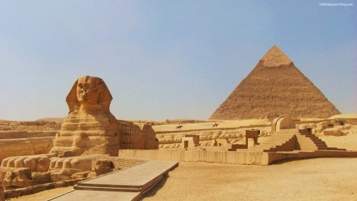
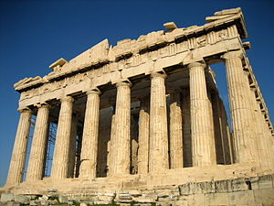
St. John’s CE School
Year 5
Class Termly Forecast
Summer Term 2019

Welcome back. We hope you had an enjoyable Easter break and are looking forward to the new term.

We are writing to inform you of the topics we will be covering this term.

In Maths this term we will be working on mental addition and subtraction; decimals, percentages and their equivalence to fractions; problem solving, reasoning and algebra; written multiplication and division; number and place value; geometry: position and direction and properties of shapes. The children will start to have weekly Mental Maths Tests in the form of Numeracy Ninja reinforcing arithmetic skills.

In English we will be covering newspaper report writing, poetry and a final narrative unit. The children have done a lot of persuasive writing in a formal style and will use these techniques to write a formal report for our school newsletter. We will also study poetry through the form of the ‘Highwayman’ which explores a depth of language and allows the children to interpret the story.
Spellings will continue to be given out on a weekly basis and will focus around Year 5 spelling rules, key words and vocabulary. Reading is an area which we will be targeting this term. Guided reading sessions will work on comprehension and understanding of texts. This will be done in both small groups and whole class sessions.

P.E. will again take place in the first half term for the whole of Tuesday afternoon. The children will be taught athletics and cricket/rounders by Mr. Gunn, Mr. Newman and Miss Mundy. Swimming will continue on Friday afternoons. Please ensure your child has the appropriate kits in school for these activities.

Our topic for the summer terms are: Ancient Egypt and maps of the world. Students will be discovering the Ancient Gods and Goddesses, building fact files, looking at the architecture of the temples and the history of how the Egyptians lived. Afterwards, the Pharaoh’s will be featured, looking at the human and geographical features and art and design during the Ancient Egyptian period. We will also look in depth at how the River Nile was used and the process of mummification.

Science will be continuing this term with a focus on the concepts of: gravity, air resistance, forces as well as earth and space.

R.E. will be focused on Understanding Faith in the Community. Students will be researching information about the London Borough of Barnet and finding out about the faiths and beliefs of the community. It will include researching of the community and how it has changed over the past 50years. Year 5 will then delve further into the religion of: Hinduism, exploring the features.

In Music this year the children will continue to have percussion lessons with Mr. Punn. During this time, the students will learn to play drums and other percussion instruments.

Year 5 will also be given weekly Italian lessons by a language specialist.

This term the class will continue to be given the chance to participate on a weekly basis in our Community Cohesion programme that links our children with Oakleigh Special School. The children will be involved in helping children and supporting them in their learning and development.

Year 5 will also be going on their school trip to Bude in May.

Homework
Will be distributed on Fridays and due Wednesdays. This includes: Mathletics, spellings and any other tasks assigned.

Can you please make sure your child comes to school with a pencil case containing the correct equipment: writing pencils, rubbers, sharpener, glue stick, ruler and a set of colouring pencils.

As the weather is becoming warmer, please can you ensure that your child comes to school with a bottle of water every day.

We look forward to an enjoyable summer term with you and your children.

Many thanks,

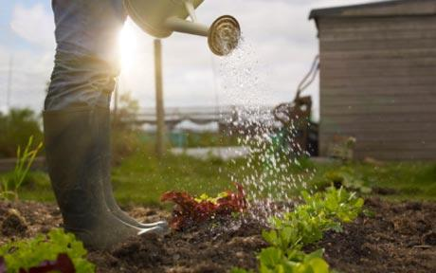
Miss Mundy

