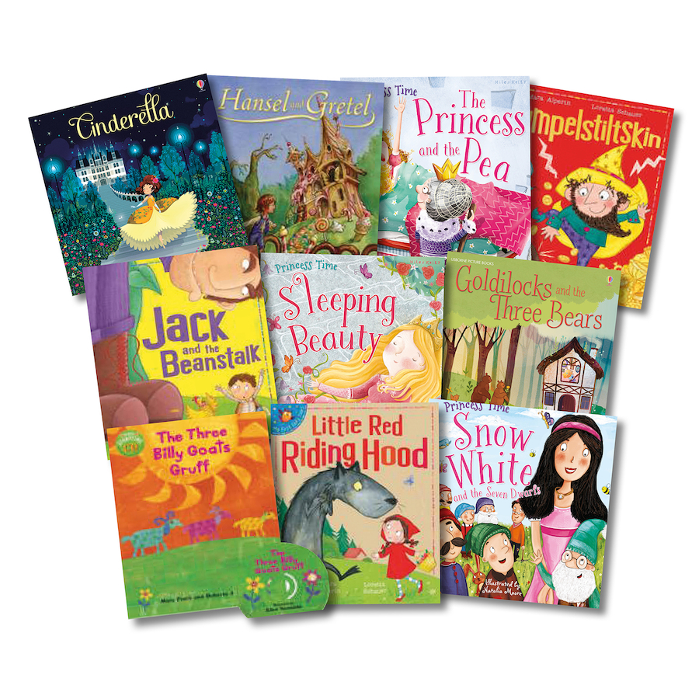
Books we are reading!

We are exploring Fairytales!

