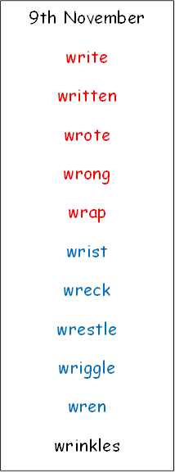

2nd November

knock

know

knee

knitting

knife

gnat

gnaw

gnash

gnome

gnarled

design

reign

19th October

See Spelling Wizard sheet

12th October

door

floor

again

wild

children

climb

parents

most

only

both

sugar

eye

could

would

should